|  |
| --- |
| 8SRM Institute of Science and Technology  Faculty of Engineering and Technology  Department of Electronics and Communication Engineering |
| 18ECC203J **MICROPROCESSOR AND MICROCONTROLLER Fifth Semester, 2021-22 (odd semester)** |

**Mini Project Report**

**Name** **:Pushpal Das**

**Register No.** **:RA1911004010565**

**Day / Session** **:**

**Venue** **: Online**

Project Title :Potentiometer reading in LCD.

Lab Supervisor :

Team Members :PUSHPAL DAS(RA1911004010565)

HRIVU DAS MUNSHI(RA1911004010566)

KAPIL DEV KUMAR TIWARY.(RA1911004010568)

|  |  |  |
| --- | --- | --- |
| **Particulars** | **Max. Marks** | **Marks Obtained** |
| Objective & Description | 05 |  |
| Result Analysis | 10 |  |
| Presentation | 10 |  |
| Report | 05 |  |
| **Total** | **30** |  |

**REPORT VERIFICATION**

**Date** **:17/10/2021**

**Staff Name**  **: Mr.R.Prithiviraj**

Potentiometer reading in LCD.

# College Name

* **SRM Institute of Science and Technology.**

## Team member details

## **TEAM MEMBER 1**

* NAME Pushpal Das.
* EMAIL ID pushpaldas2001@gmail.com.
* DISCIPLINE Electronics and Communication Engineering.
* YEAR 3rd year.
* MOBILE 8910497557.

## **TEAM MEMBER 2**

* NAME Hrivu Das Munshi.
* EMAIL ID hd9713@srmist.edu.in
* DISCIPLINE Electronics and Communication Engineering**.**
* YEAR 3rd year**.**
* MOBILE 8436155632.

## **TEAM MEMBER 3**

* NAME Kapil Dev Kumar Tiwary.
* EMAIL ID kt6757@srmist.edu.in
* DISCIPLINE Electronics and Communication Engineering.
* YEAR 3rd year.
* MOBILE 77799 24719

Introduction

The main objective of our team is to make a reading through the potentiometer and successfully displaying it in the LED. Here, it is done on a software called proteus, ADC interfacing with 8051 and LCD display with using proteus.

As we all know 8051 do not have inbuilt ADC so we are using external IC of 8bit and 1 channel so that we can send Analog Signal to 8051.

As IC0804 is 8-bit ADC-

1. Max decimal value of 8 bit -255

2. Min decimal value of 8 bit - 000

As analog signal changes Decimal count on LCD display changes: - Analog Signal Decimal Value on LCD 100% - 255 50% - 128 0% - 000

Embedded Programming is done by using Microvision Keil 5 software.

Components required-

Software Components Required-

1.Proteus professional

The Proteus Design Suite combines ease of use with a powerful feature set to enable the rapid design, test and layout of professional printed circuit boards

2. µVision IDE

The µVision IDE combines project management, run-time environment, build facilities, source code editing, and program debugging in a single powerful environment. µVision is easy-to-use and accelerates your embedded software development. µVision supports multiple screens and allows you to create individual window layouts anywhere on the visual surface.

Hardware Components Required-

1. **8051 Microcontroller (AT89C51)**

The **AT89C51** is an age old 8-bit microcontroller from the Atmel family. It works with the popular 8051 architecture and hence is used by most beginners till date. It is a 40 pin IC package with 4Kb flash memory. It has four ports and all together provide 32 Programmable GPIO pins. It does not have in-built ADC module and supports only USART communication. Although it can be interfaced with external **ADC IC** like the [ADC084](https://components101.com/adc0804-pinout-datasheet) or the [ADC0808](https://components101.com/adc0808-pinout-features-datasheet).

The **AT89C51** is no longer in production and Atmel does not support new design. Instead, the new AT89S51 is recommended for new applications. But, since the AT89C51 has a strong community support if your motive is to learn embedded then AT89C51 can still be a good choice.

2. **Liquid Crystal Display (16*2 LCD Display)**

An LCD (Liquid Crystal Display) screen is an electronic display module and has a wide range of applications. A 16x2 LCD display is very basic module and is very commonly used in various devices and circuits. A 16x2 LCD means it can display 16 characters per line and there are 2 such lines. In this LCD each character is displayed in 5x7 pixel matrix. The 16 x 2 intelligent alphanumeric dot matrix display is capable of displaying 224 different characters and symbols. This LCD has two registers, namely, Command and Data.

Command register stores various commands given to the display. Data register stores data to be displayed. The process of controlling the display involves putting the data that form the image of what you want to display into the data registers, then putting instructions in the instruction register. In your arduino project [Liquid Crystal Library](https://www.arduino.cc/en/Reference/LiquidCrystal) simplifies this for you so you don't need to know the low-level instructions. Contrast of the display can be adjusted by adjusting the potentiometer to be connected across VEE pin.

3. **ADC IC0804 (1 channel- Only one analog signal can connect) (8bit ADC- Analog Signal converted into 8bit digital signal)**

A converter that is used to change the analog signal to digital is known as an analog to digital converter or ADC converter. This converter is one kind of integrated circuit or IC that converts the signal directly from continuous form to discrete form. This converter can be expressed in A/D, ADC, A to D. The inverse function of DAC is nothing but ADC. The analog to digital converter symbol is shown below.

The process of converting an analog signal to digital can be done in several ways. There are different types of ADC chips available in the market from different manufacturers like the ADC08xx series. So, a simple ADC can be designed with the help of discrete components.

The main features of ADC are sample rate and bit resolution.

* The sample rate of an ADC is nothing but how fast an ADC can convert the signal from analog to digital.
* Bit resolution is nothing but how much accuracy can an analog to digital converter can convert the signal from analog to digital.

One of the major benefits of ADC converter is the high data acquisition rate even at multiplexed inputs. With the invention of a wide variety of ADC [integrated circuits](https://www.elprocus.com/different-types-of-integrated-circuits/) (IC’s), data acquisition from various sensors becomes more accurate and faster. Dynamic characteristics of the high-performance ADCs are improved measurement repeatability, low power consumption, precise throughput, high linearity, excellent Signal-to-Noise Ratio (SNR), and so on.

A variety of applications of the ADCs are measurement and control systems, industrial instrumentation, communication systems, and all other sensory-based systems. Classification of ADCs based on factors like performance, bit rates, power, cost, etc.

4. **Potentiometer**

A **potentiometer** is a three-[terminal](https://en.wikipedia.org/wiki/Terminal_(electronics)) [resistor](https://en.wikipedia.org/wiki/Resistor) with a sliding or rotating contact that forms an adjustable [voltage divider](https://en.wikipedia.org/wiki/Voltage_divider).[[1]](https://en.wikipedia.org/wiki/Potentiometer#cite_note-1) If only two terminals are used, one end and the wiper, it acts as a **variable resistor** or **rheostat**.

The measuring instrument called a [potentiometer](https://en.wikipedia.org/wiki/Potentiometer_(measuring_instrument)) is essentially a [voltage divider](https://en.wikipedia.org/wiki/Voltage_divider) used for measuring [electric potential](https://en.wikipedia.org/wiki/Electric_potential) (voltage); the component is an implementation of the same principle, hence its name.

Potentiometers are commonly used to control electrical devices such as volume controls on audio equipment. Potentiometers operated by a mechanism can be used as position [transducers](https://en.wikipedia.org/wiki/Transducer), for example, in a [joystick](https://en.wikipedia.org/wiki/Joystick). Potentiometers are rarely used to directly control significant power (more than a [watt](https://en.wikipedia.org/wiki/Watt)), since the power dissipated in the potentiometer would be comparable to the power in the controlled load

5. **Resistor (10K ohm)**

A 10k ohm resistor has **4 colour bands: brown, black, orange, and gold for 5% tolerance**, respectively. A 1k ohm resistor has 4 colour bands: brown, black, red, and gold for 5% tolerance, respectively. Commonly used in **breadboards and perf boards**, these 10K resistors make excellent pull-ups, pull-downs, and current limiters. To determine the value of a given resistor look for the gold or silver tolerance band and rotate the resistor as in the photo on the left.

6. **Capacitor (150uF)**

A **capacitor** is a device that stores [electrical energy](https://en.wikipedia.org/wiki/Electrical_energy) in an [electric field](https://en.wikipedia.org/wiki/Electric_field). It is a [passive](https://en.wikipedia.org/wiki/Passivity_(engineering)) [electronic component](https://en.wikipedia.org/wiki/Electronic_component) with two [terminals](https://en.wikipedia.org/wiki/Terminal_(electronics)).

The effect of a capacitor is known as [capacitance](https://en.wikipedia.org/wiki/Capacitance). While some capacitance exists between any two electrical conductors in proximity in a [circuit](https://en.wikipedia.org/wiki/Electric_circuit), a capacitor is a component designed to add capacitance to a circuit. The capacitor was originally known as a **condenser** or **condensator**.[[1]](https://en.wikipedia.org/wiki/Capacitor#cite_note-duff-1) This name and its [cognates](https://en.wikipedia.org/wiki/Cognate) are still [widely used in many languages](https://en.wiktionary.org/wiki/capacitor#translations), but rarely in English, one notable exception being [condenser microphones](https://en.wikipedia.org/wiki/Condenser_microphones), also called capacitor microphones.

**7.Respack8**

Respack is a device just similar to resistance box used for the variation of the resistances as per use of the circuit but there is subtle difference in the respack that is the resistance present in it are of same value and here the respack used RESPACK-8 which consists of 8 resistances of equal value i.e. 1 K ohm.

**CODE**

#include<reg51.h>

sfr mydata = 0x90;

sbit rd= P2^5;

sbit wr= P2^6;

sbit intr= P2^7;

sbit RS = P2^0;

sbit EN = P2^1;

//(0x90)is address of port1, else you can write as : #defintre mydata P1

void delay(int n)

{

int i,j;

for(i=0;i<n;i++)

for(j=0;j<255;j++);

}

void lcd_cmd(char a)

{

P3 = a;

RS = 0;

EN = 1;

delay(10);

EN = 0;

}

void lcd_data(char a)

{

P3 = a;

RS = 1;

EN = 1;

delay(10);

EN = 0;

}

void display(char *ptr)

{

while(*ptr != '\0')

{

lcd_data(*ptr);

ptr++;

}

}

void main()

{

unsigned char value;

char temp[4];

int i=0;

lcd_cmd(0x01); //clear screen

lcd_cmd(0x0E); //Display On, Cursor Blinking

lcd_cmd(0x38); //2 lines and 5*7 matrix

lcd_cmd(0x80); //Force Cursor to beginning of first

display("ADC Value=");

lcd_cmd(0xC0);

//mydata = 0xEF;

intr = 1;

rd = 1;

wr = 1;

while(1)

{

lcd_cmd(0xC0);

wr = 0;

wr = 1;

while(intr==1);

rd=0;

value = mydata;

while(i<3)

{

temp[i] = (value%10) + '0'; // For converting into ASCII

value = value / 10;

i++;

}

for(i=2;i>=0;i--)

{

lcd_cmd(0x06);

lcd_data(temp[i]);

}

i=0;

delay(1000);

rd = 1;

} //Program_for_all

Output.

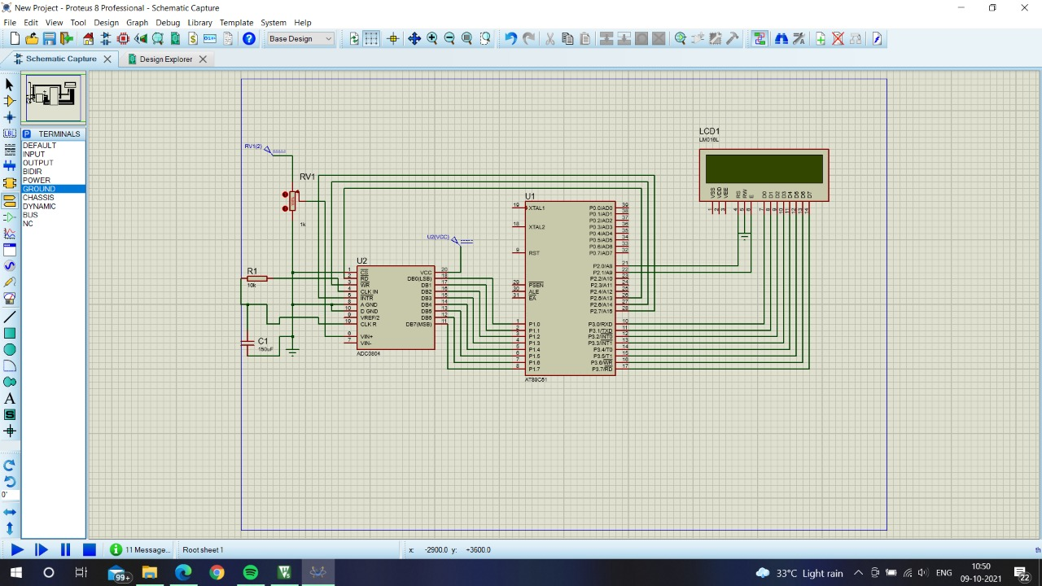

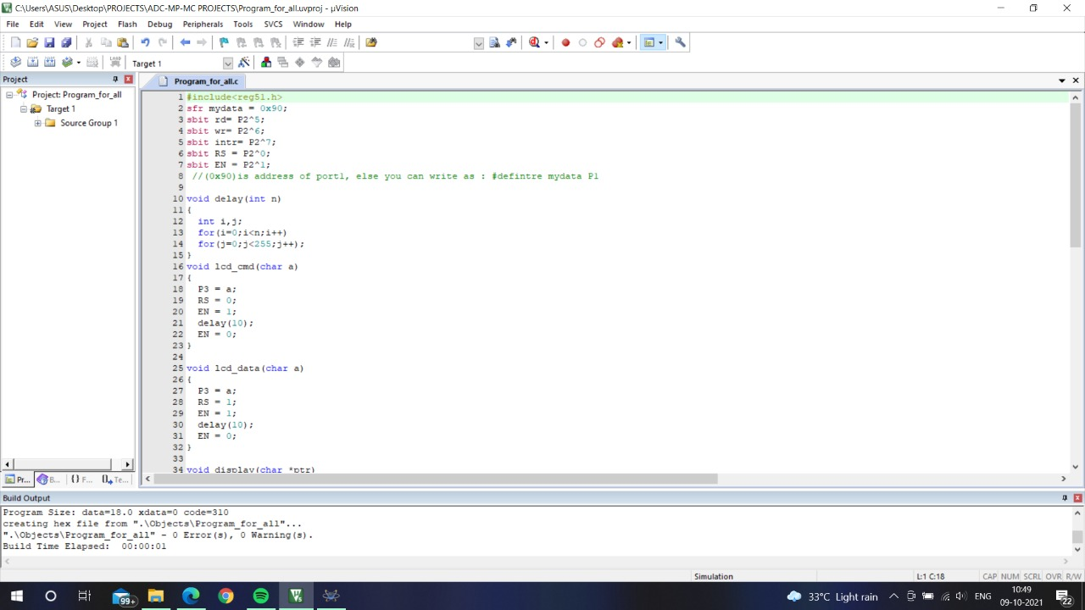

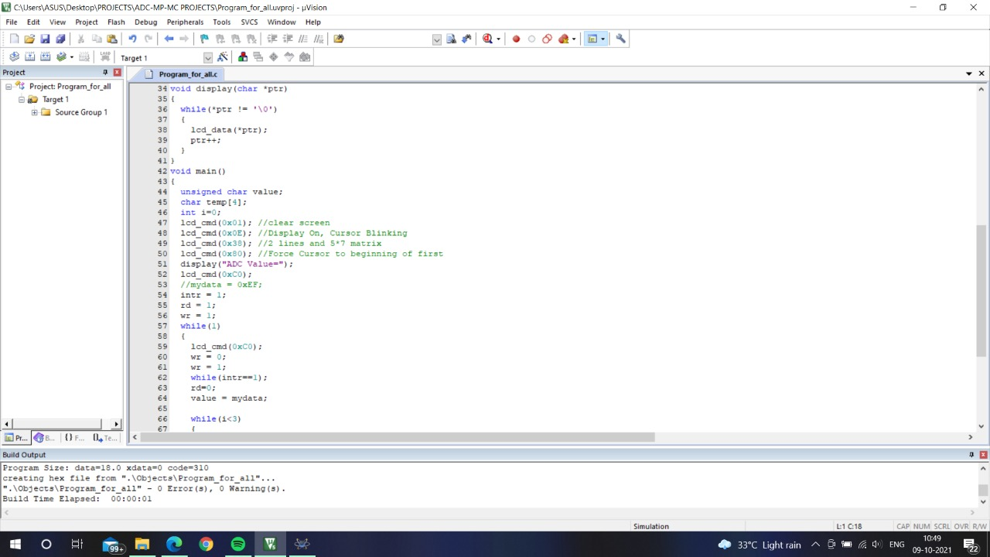



**DRIVE LINK(video simulation)**

[**https://drive.google.com/file/d/1J4LxQgVJVo9M_aEcPL1wPFIpmVUnJk3S/view?usp=sharing**](https://drive.google.com/file/d/1J4LxQgVJVo9M_aEcPL1wPFIpmVUnJk3S/view?usp=sharing)

**DRIVE LINK(files)**

**https://drive.google.com/drive/folders/1nfXYJJkRycaGNtQe5DfhouKXekj5EEcq?usp=sharing**

Conclusion

Analog to digital conversion is a very important task in [embedded electronics](https://circuitdigest.com/embedded), as most of the sensors provide output as analog values and to feed them into microcontroller which only understand binary values, we have to convert them into Digital values. So, to be able to process the analog data, microcontrollers need [**Analog to Digital Converter**](https://circuitdigest.com/tutorial/what-is-adc-analog-to-digital-converters).

Some microcontroller has inbuilt ADC like Arduino, MSP430, PIC16F877A but some microcontrollers don’t have it like 8051, Raspberry Pi etc and we have to use some external Analog to digital converter ICs like [ADC0804](https://circuitdigest.com/electronic-circuits/adc0804-introduction), ADC0808. Below you can find various examples of ADC with different microcontrollers.